**Members**

Lisa Chen

**File Listing**

* **searchAgents.py** 
  + File defining search agents and search problems
  + Only CornersProblem class with all its methods implemented

**What I’ve learned**

I struggled a lot on this problem in trying to figure out how I was supposed to define the isGoalState() and getSuccessors(). Many times Pacman would get stuck, where when I debug, I realized is because there is an issue with my logic. Originally, even though I did define isGoalState() correctly by stating that all four corners were found, there was a problem with determining how to get to all 4 corners when backtracking is absolutely needed when you look at the maze. It wasn’t until with some help with asking my friends that I should actually change the state when Pacman finds a corner; this way, previous “visited” would not match anymore since the state doesn’t match.

Question 5: Pacman Terminal Prints

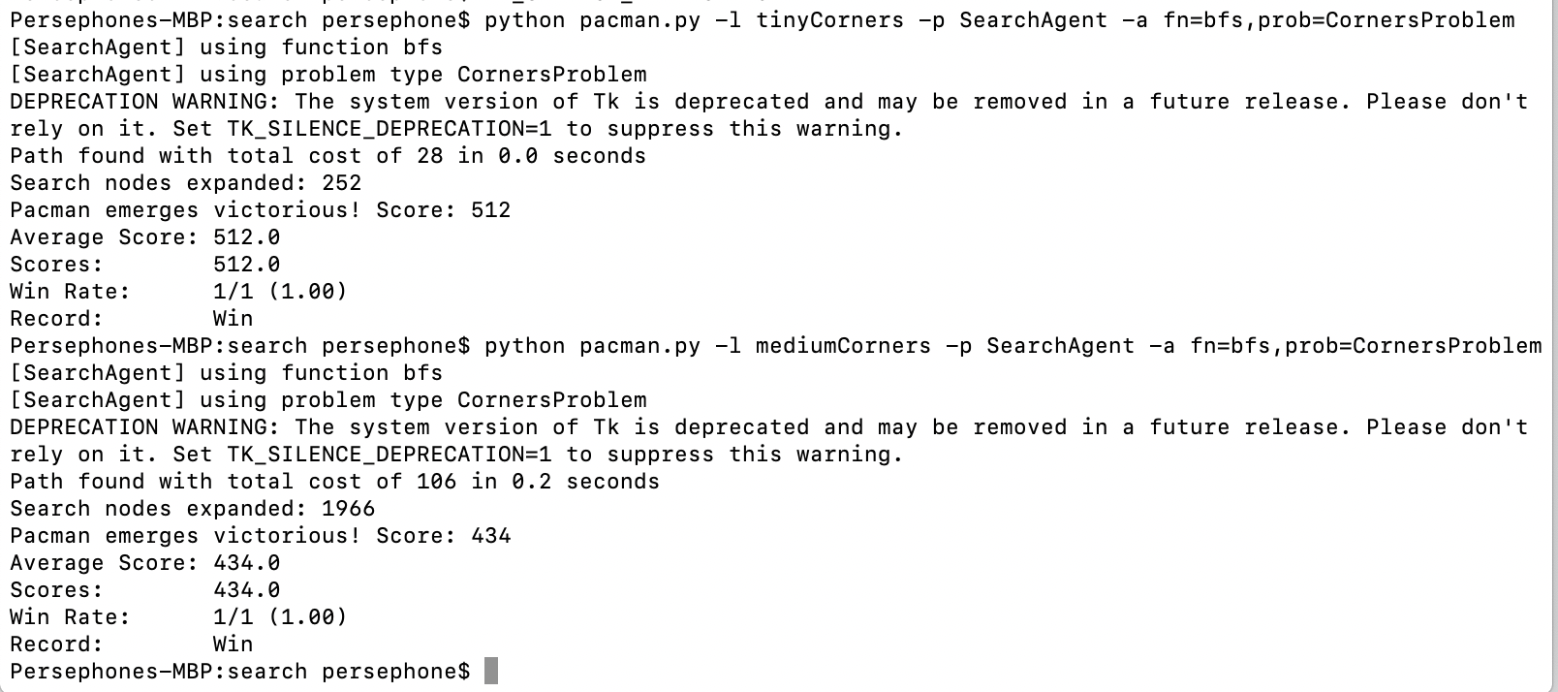

Autograder Question 5

